🚀 API 2: Template Mapping
Endpoint: /template-mapping
Method: POST
Purpose:
To automatically fill a Word document template (stored on SharePoint) with dynamic data by replacing placeholders, and then upload the completed document back to SharePoint.

🧠 Conceptual Understanding
Imagine you have a master document template on SharePoint like a contract agreement, with placeholders such as:
Dear {cm_customer},
This agreement starts on {cm_startdate} and ends on {cm_enddate}.
The API takes a JSON payload (like your test case) containing real values for these placeholders and produces a ready-to-use document — no manual editing needed.
This is extremely useful for automating business workflows like:
- Generating contract agreements
- Auto-filling purchase orders or invoices
- Creating personalized reports

🧩 API #3: RFP Creation
Route
POST /rfp-creation

🎯 Purpose
This API automates the creation of RFP (Request for Proposal) documents using reference documents and instructions.
It pulls RFP files and answer key documents from SharePoint, processes them using AI embeddings, and generates a new RFP document automatically, all handled in the background.
Think of it as:
👉 “You give me old RFP docs + answer keys + some text instructions → I’ll generate a new, complete proposal document and upload it back to SharePoint.”
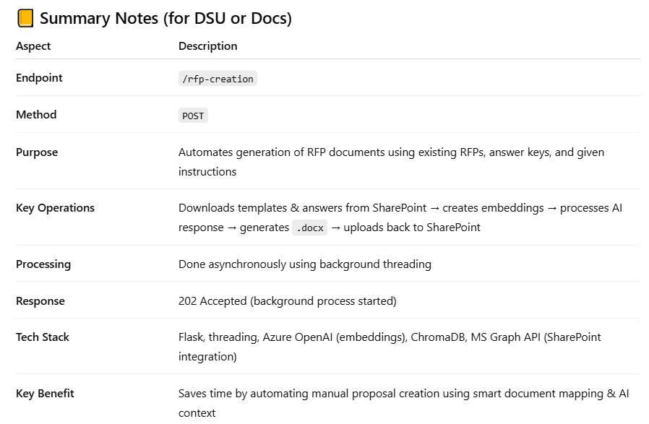
🗂️ 1️⃣ rfp_folder_name
➤ Purpose:
This is the name of the SharePoint folder where your RFP template(s) or question documents are stored.
• The function get_specific_files_from_folder() connects to SharePoint.
• It searches for the file(s) in your rfp_files list (like "RFP - Airbus to Imperium.docx") inside the folder named rfp_folder_name.
• Then it downloads those files to the local temp folder.

📚 2️⃣ answer_folder
➤ Purpose:
This is the SharePoint folder containing your company’s answer materials or reference documents — basically, the “knowledge base” the AI will use to generate answers.

➤ What happens:
- The function fetches all documents inside that folder.
- Each file is downloaded and read.
- Then, those files are embedded into the AI’s vector database (via Azure OpenAI embeddings).
- The AI uses this context to craft relevant responses to the RFP questions.

⚙️ API 4: Proposal Feedback
Purpose
To analyze a proposal document (e.g., a company’s bid) and generate structured feedback on how well it matches the given RFP requirements.

🧩 Endpoint Overview
Property | Description
URL | /proposal-feedback
Method | POST
Description | Generates feedback on a proposal by comparing it with RFP requirements.
Input Type | JSON
Output | JSON with AI-generated feedback

🧩 API 5: Q&A Document Acceptance
URL: /qna-document-acceptance
Method: POST

🧠 1️⃣ Purpose — What It Does and Why It Exists
This API automates the process of matching questions and answers from different documents stored on SharePoint.
Think of it like this:
- You have one document (say “questions.docx”) that contains a list of questions from an RFP or tender.
- You have another folder containing answer key documents (previously prepared responses, templates, FAQs, etc.).
- The system tries to find the best matching answer for each question using a semantic similarity threshold (AI-based matching).
Then, instead of directly inserting those answers into a document (like scenario 1 did),
it returns the results as JSON → so a user can review, edit, or reject answers before final acceptance.
✅ Goal: Give user full control over which AI-suggested answers to keep or modify before generating the final populated document.
📊 6️⃣ Summary (for your DSU or notes)
Concept | Description
Purpose | Matches Q&A pairs from documents using AI similarity
Input | Question doc, answer folder, and similarity threshold
Processing | Embedding-based similarity using find_answers()
Output | JSON mapping each question → best answer + confidence score
Result Location | Returned in API response (not uploaded to SharePoint)
Backstory | Built to let users verify AI-generated Q&A matches before document filling
Cleanup | Deletes temp files after each run

API 6
🧩 Overview
URL: /populate-answers
Method: POST
Purpose:
Takes the user-reviewed or accepted Q&A pairs (JSON format) and writes those answers back into the original question document, then uploads the filled document to SharePoint.
So —
1️⃣ /qna-document-acceptance → compares Q&A docs, finds best answers, returns them.
2️⃣ User reviews/edits answers manually (front-end step).
3️⃣ /populate-answers → receives final Q&A pairs, fills them into the question doc, and re-uploads the completed file. ✅
🗂️ Folder & File Flow Summary
Stage | Action | Source/Target | Tool Used
1 | Download questions_file_name | SharePoint (read drive) | get_sharepoint_url()
2 | Process (fill answers) | Temporary local folder | fill_answers_for_questions()
3 | Upload final doc | SharePoint (write/upload drive) | upload_to_sharepoint()

🧠 Key Points
- This is final output API in the Q&A chain.
- Temp files are cleaned automatically after upload.
- If upload_file_name is not given, system creates:
"originalfilename-populated-answers.docx"
- The processed document will appear in your SharePoint drive configured for uploads (check your .env READ_DRIVE_ID or WRITE_DRIVE_ID if separated).

🧩 API 7
URL: /generate_loss_report
Method: POST
Purpose:
Generates a loss report (in Markdown format) for a company — usually related to product or vaccine losses.
This was developed for Medmard, so it focuses on pharmaceutical or vaccine-related loss analytics.

🧠 High-Level Flow
1️⃣ Receives a company name and document filename (usually product info).
2️⃣ Downloads that .docx file from SharePoint.
3️⃣ Extracts key product/service details from the doc.
4️⃣ Runs an AI workflow using LangGraph to research, summarize, and report product loss info.
5️⃣ Returns the full loss report (as Markdown text) in JSON.

🧩 Purpose of /document_tagging API
This API’s job is to:
- Download a .docx file from SharePoint.
- Analyze its contents using Azure OpenAI.
- Tag each page or section based on the content (like Finance, Legal, Marketing, etc.).
- Add comments or an index inside the document (so users can easily navigate by tag).
- Upload the tagged document back to SharePoint.

⚙️ Workflow Summary
Here’s what happens step-by-step inside the function:
Step | Action | Description
1 | Read input data | Takes JSON with filename, upload name, and SharePoint credentials.
2 | Create temp files | Makes temporary .docx copies — one for download, one for processed output.
3 | Download file | Uses download_sharepoint_file() to fetch from SharePoint → saves locally as temp_doc_path.
4 | Tag the file | Uses tag_docx_file() to read document text, call Azure OpenAI, and identify what each page talks about. It writes tags/comments in a new version saved at temp_output_path.
5 | Upload new file | Uses upload_to_sharepoint() to push the new tagged version back to the same (or target) drive.
6 | Clean up temp files | Deletes local temporary files after upload.
7 | Return response | Returns {"message": "File tagged successfully and uploaded to SharePoint."}.

🧩 API Overview — /map_pricing_table
🎯 Purpose
To automatically fill (map) pricing data into a Word document’s table template.
This API:
- Downloads a DOCX template (usually containing placeholders like {name}, {price}, {country}) from SharePoint.
- Replaces the placeholders in a pricing table with actual data (provided in JSON).
- Uploads the completed document back to SharePoint.
It’s part of the Finance & Operations automation pipeline for Medmard.

⚙️ End-to-End Flow
Step | Action | Description
1 | Receive Request (JSON) | Includes file name, pricing data, and SharePoint credentials.
2 | Download DOCX | Uses get_sharepoint_url() + requests.get() to fetch the document from SharePoint.
3 | Create Temp Paths | Saves the downloaded document to a temporary file and prepares an output path.
4 | Map Data | Calls pricing_table() to replace placeholders {} with real pricing values.
5 | Upload Back | Uses upload_to_sharepoint() to upload the filled version.
6 | Clean Up | Deletes all temporary files and folders.

Feature / Behavior | v1 | v2 | v3
Validation of inputs | ❌ Minimal validation | ✅ Proper validation of required SharePoint & OData params | ⚠️ Minimal validation (not as strict as v2)
Purpose | Replace non-matching clauses with standard ones | Identify and categorize clauses (no replacements) | Replace or highlight clauses (user-configurable)
State fields | all_changes → stores replacement details | all_identifications → stores clause identification info | all_changes again, but enhanced with replace & highlight flags
Customization options | None | None | ✅ Adds replace and highlight flags for flexible behavior
LLM-powered summary | ❌ None | ❌ None | ✅ Generates AI summary of all contract changes using LLM
Outputs | Detailed JSON list of changes | JSON list of identified clause categories | JSON list of changes + AI textual summary
Use case | Automated clause replacement | Clause detection / auditing | Clause replacement + summarization (hybrid)
Upload back to SharePoint | ✅ Yes | ✅ Yes | ✅ Yes
Code readability | Simple | Better structured | Most advanced but longer due to LLM handling

